Computer Networks
Lab 06
Syed Huzaifa Ali
23K-0004

Task 01:
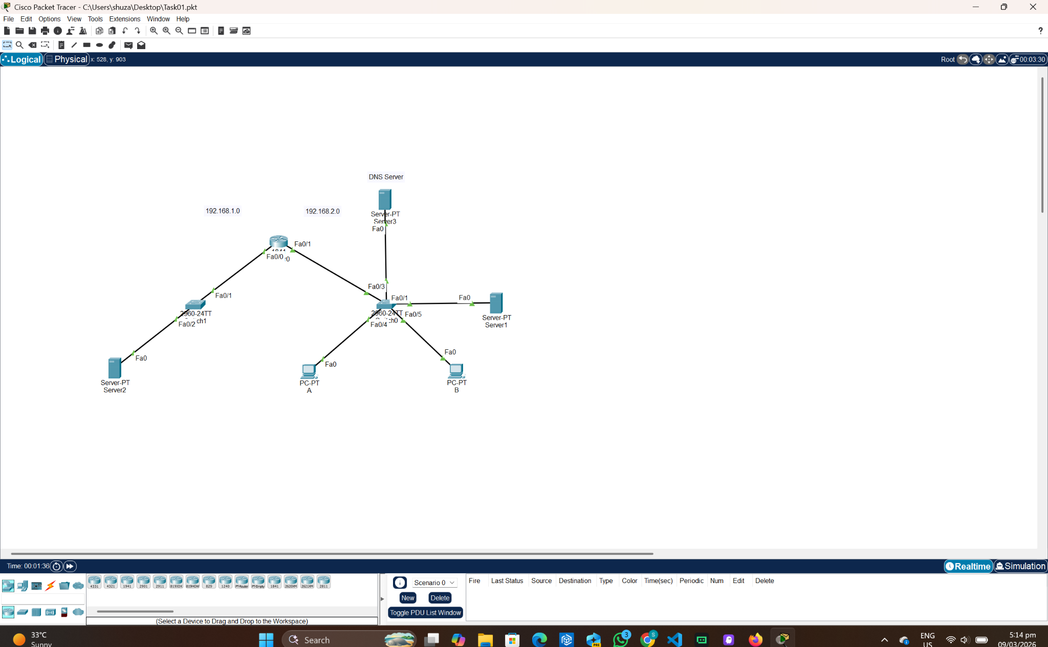

Server 1:
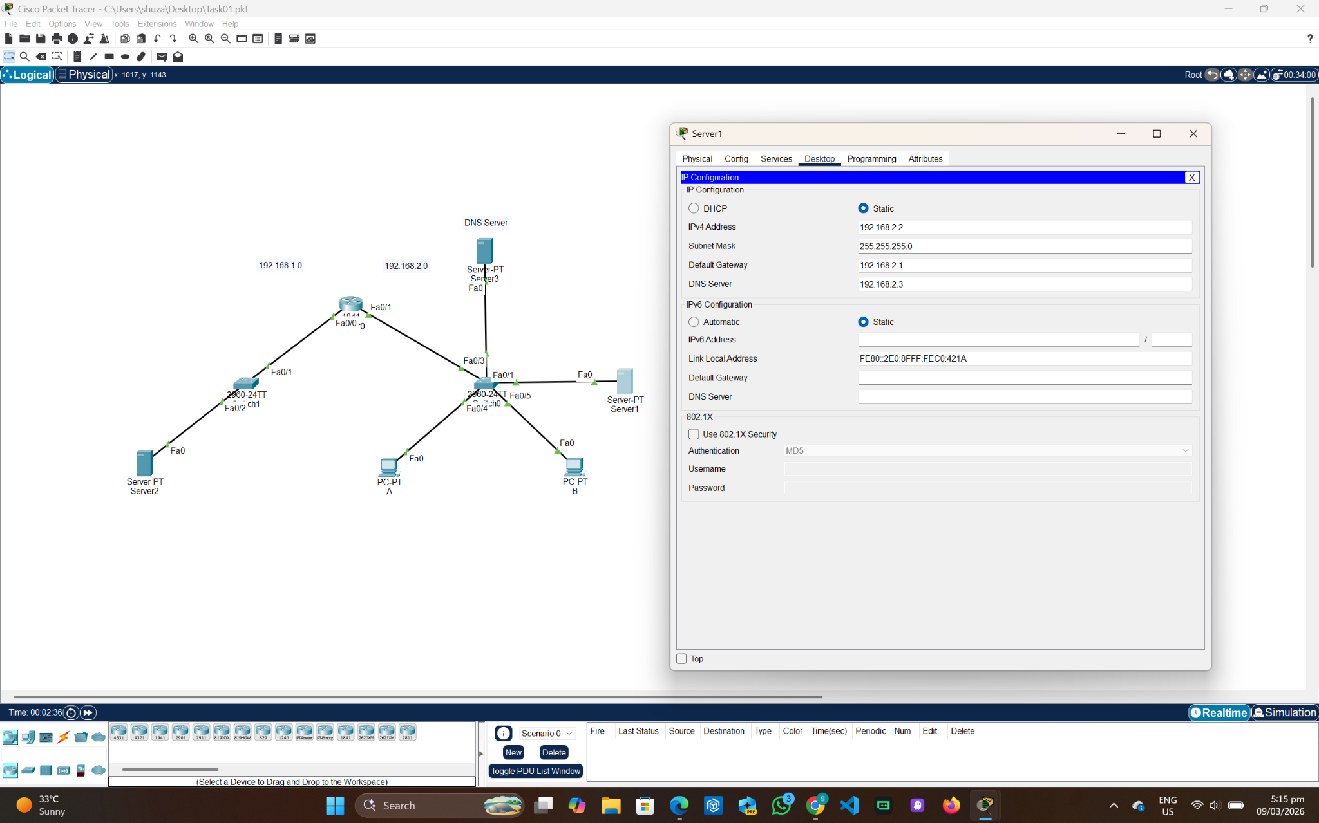

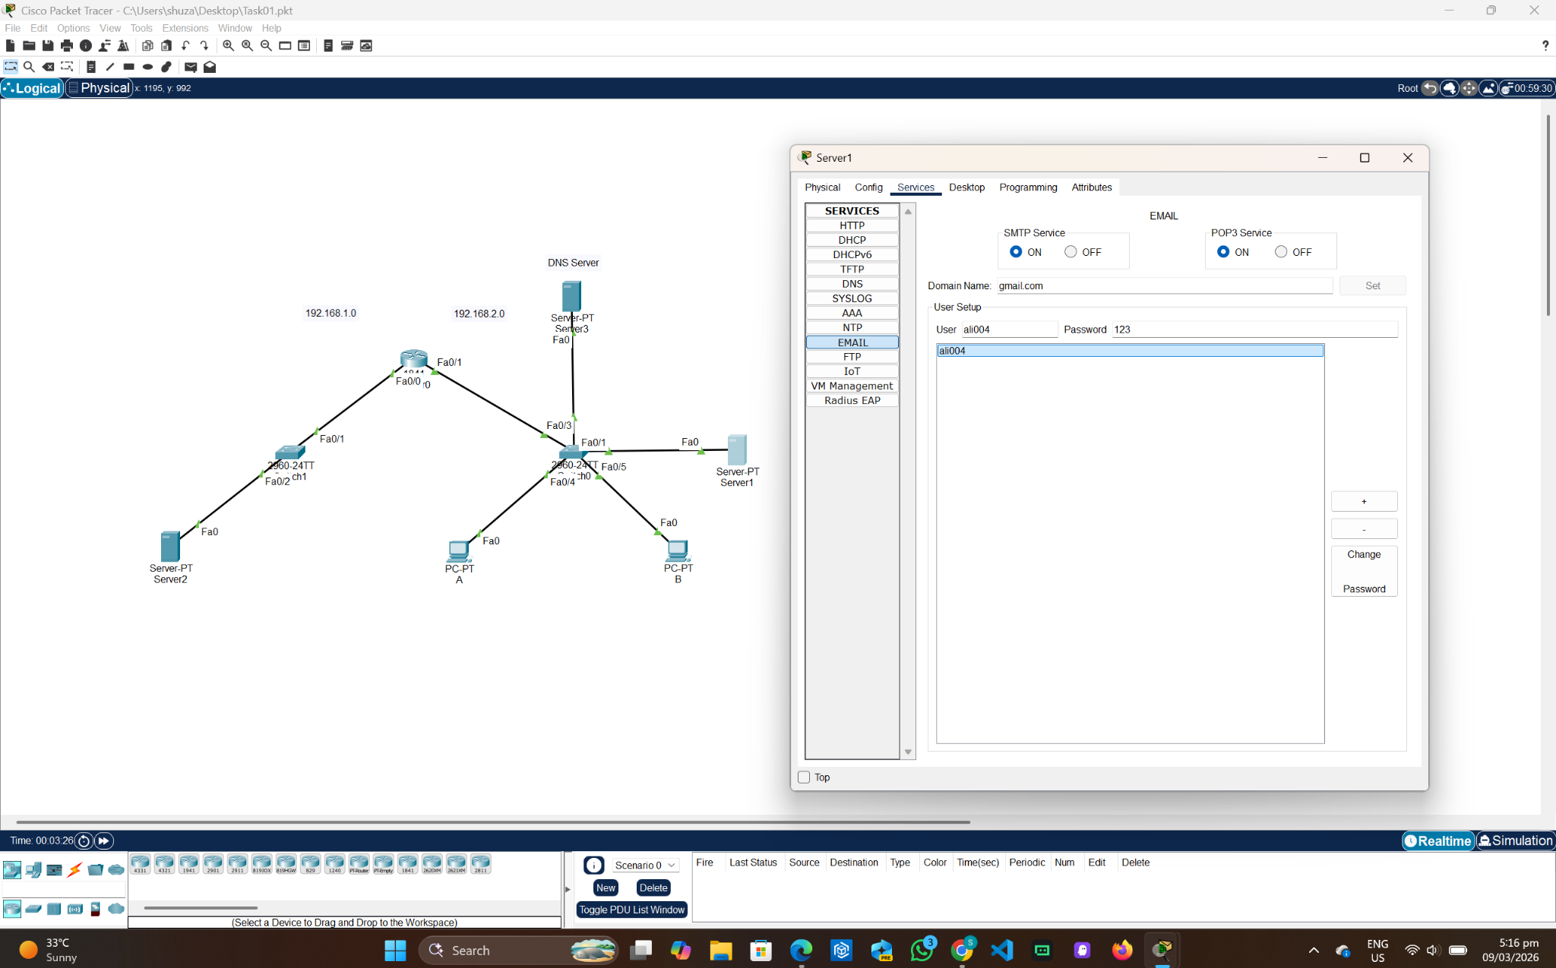
Server 2:
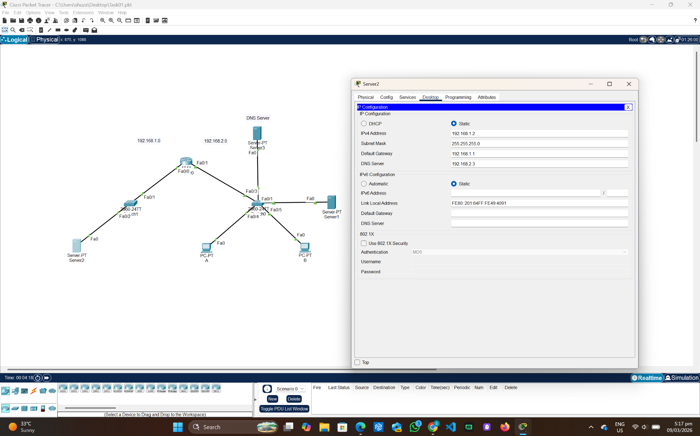

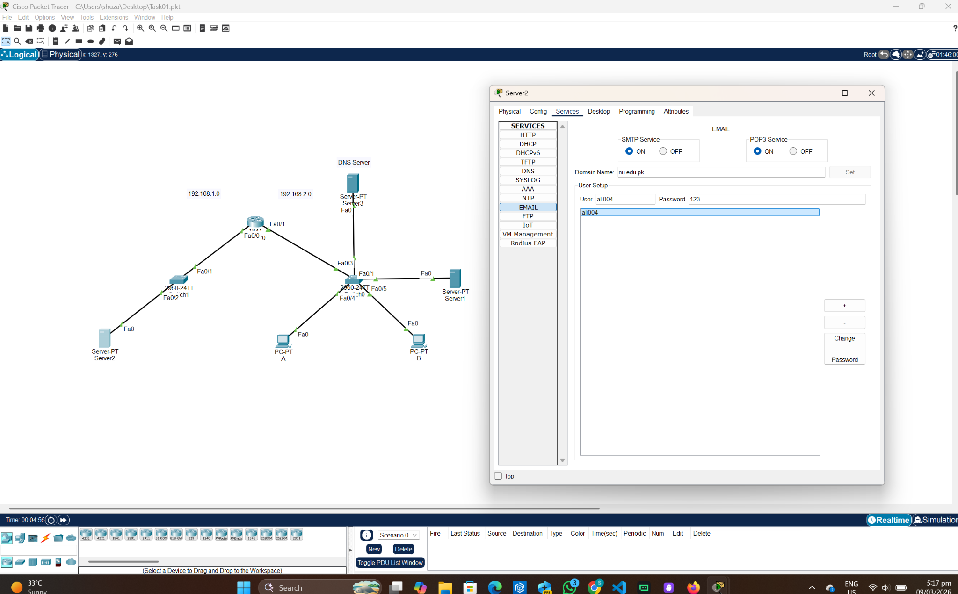
Server 3 (DNS):
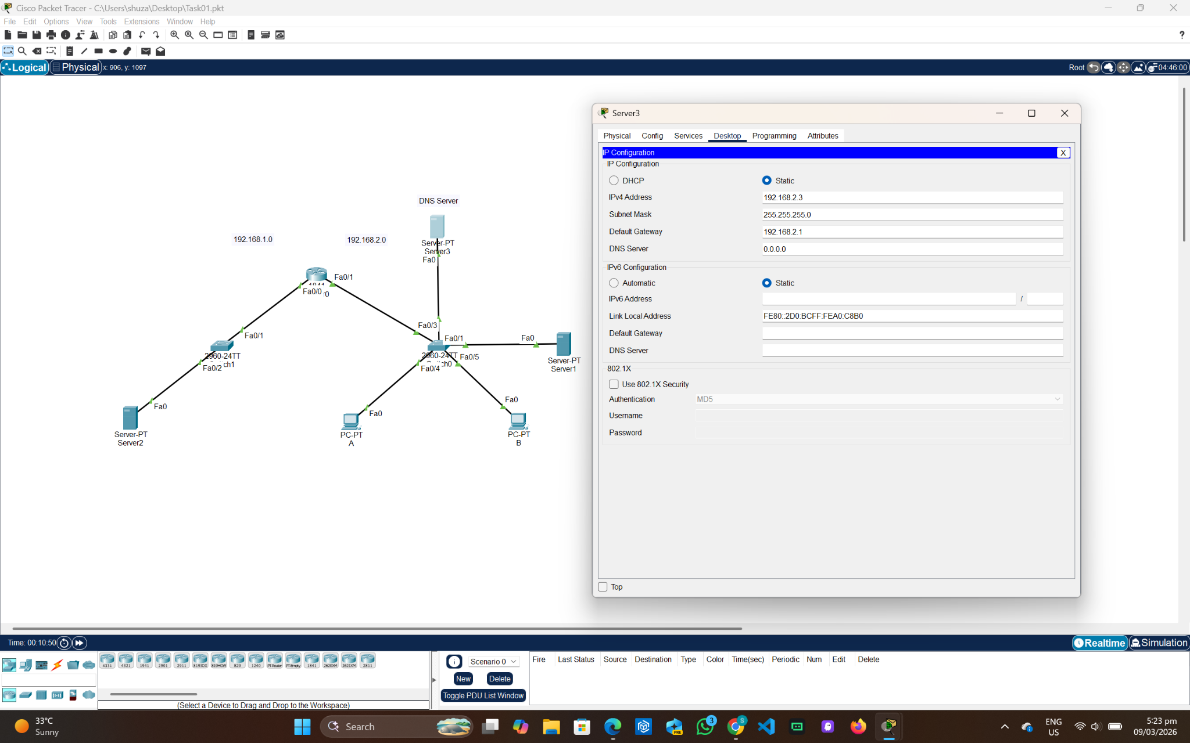

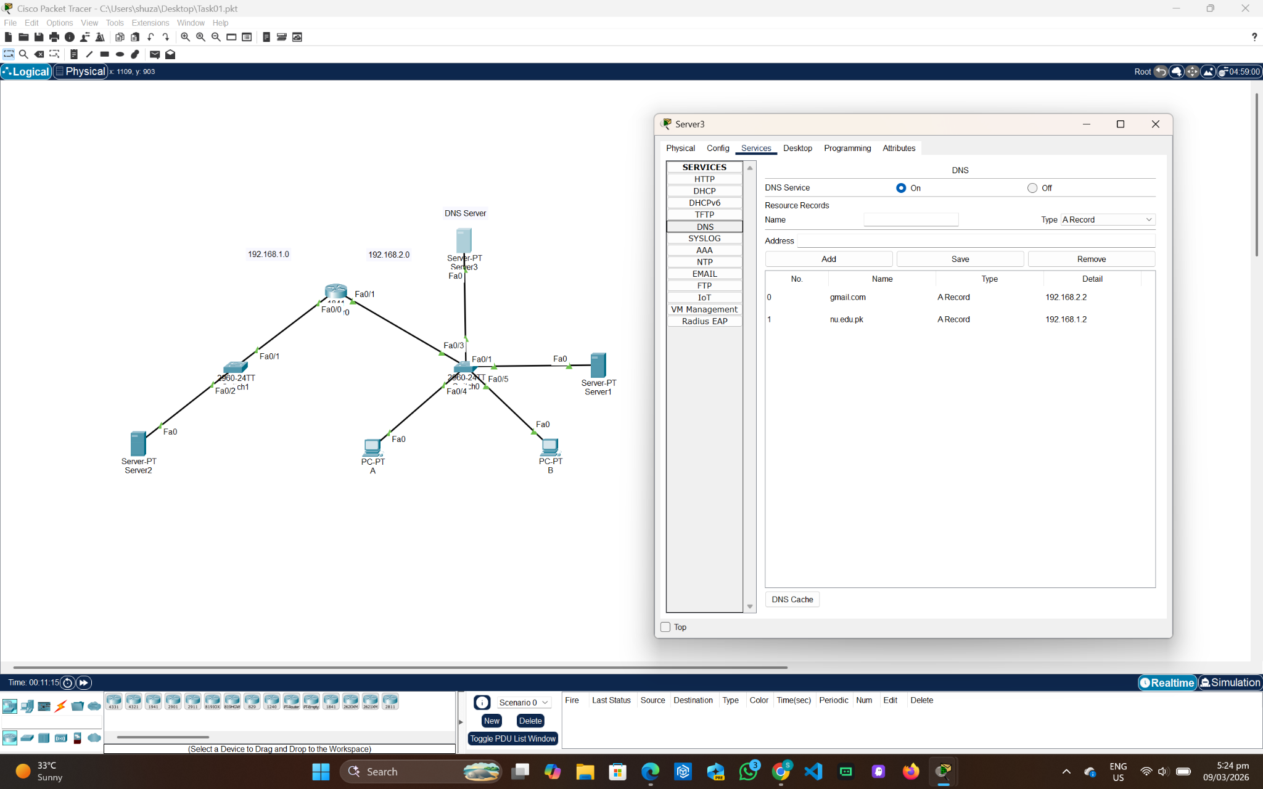
Router:
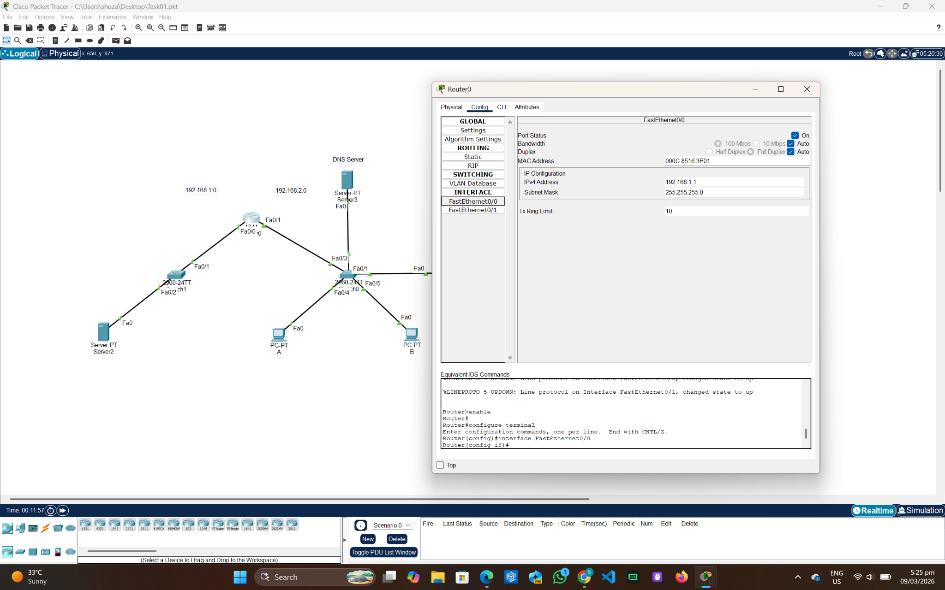

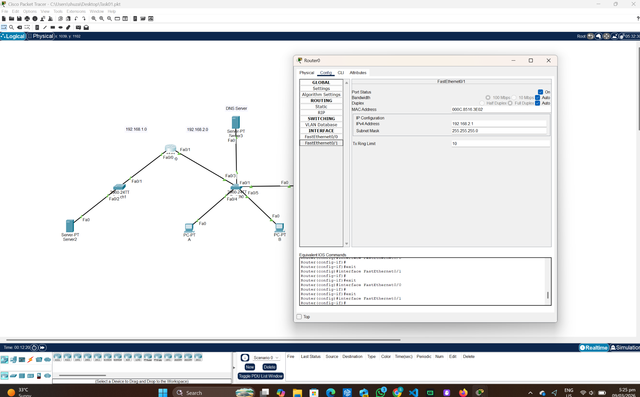
PC-A:
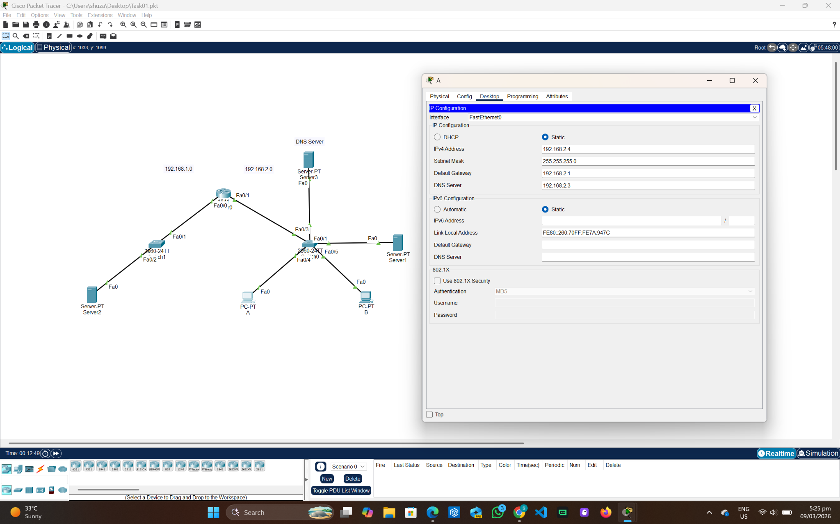
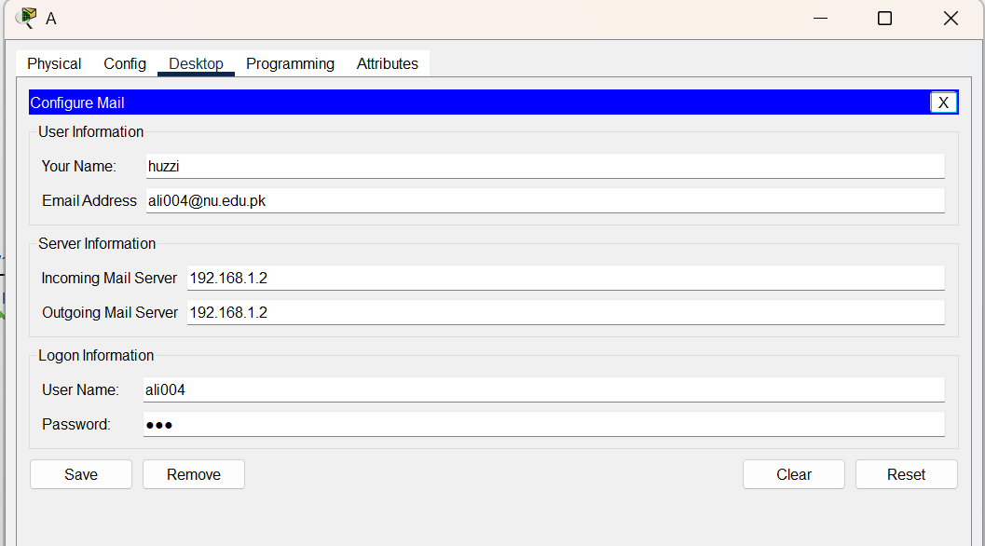

PC-B:
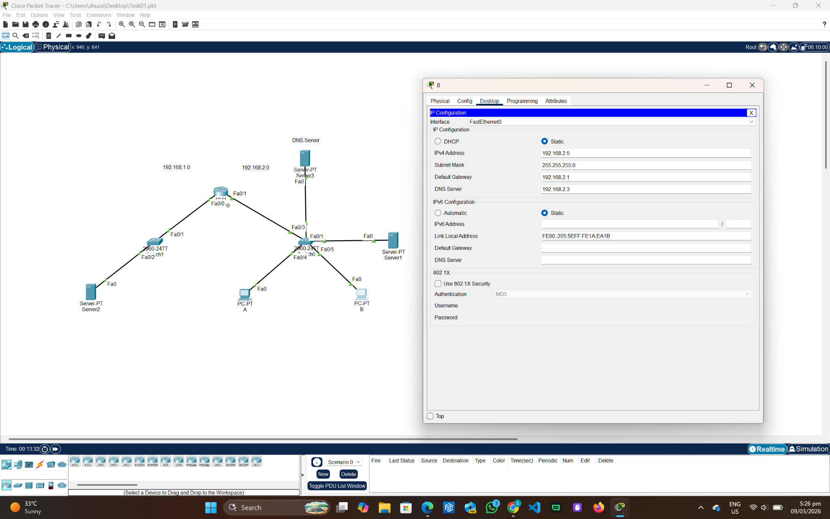

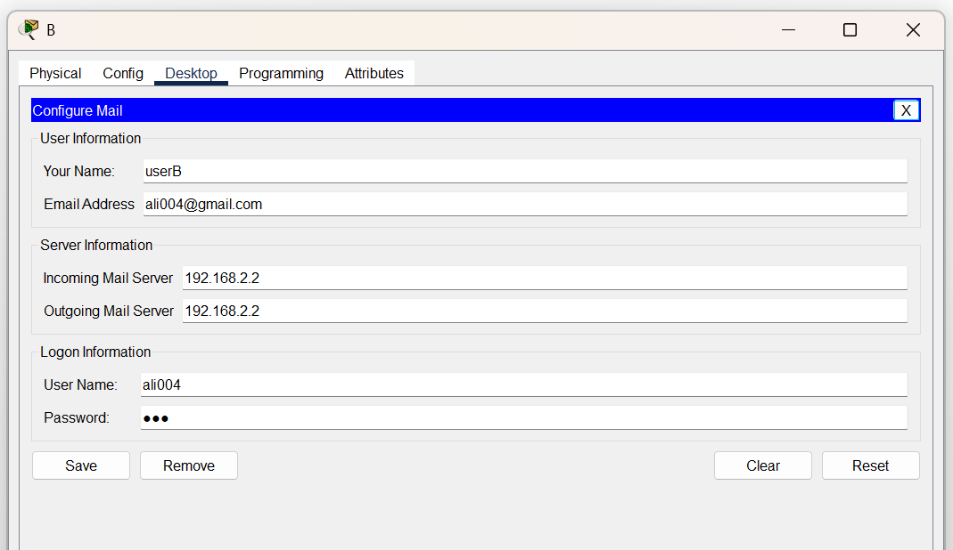
Emails between PC A and B:
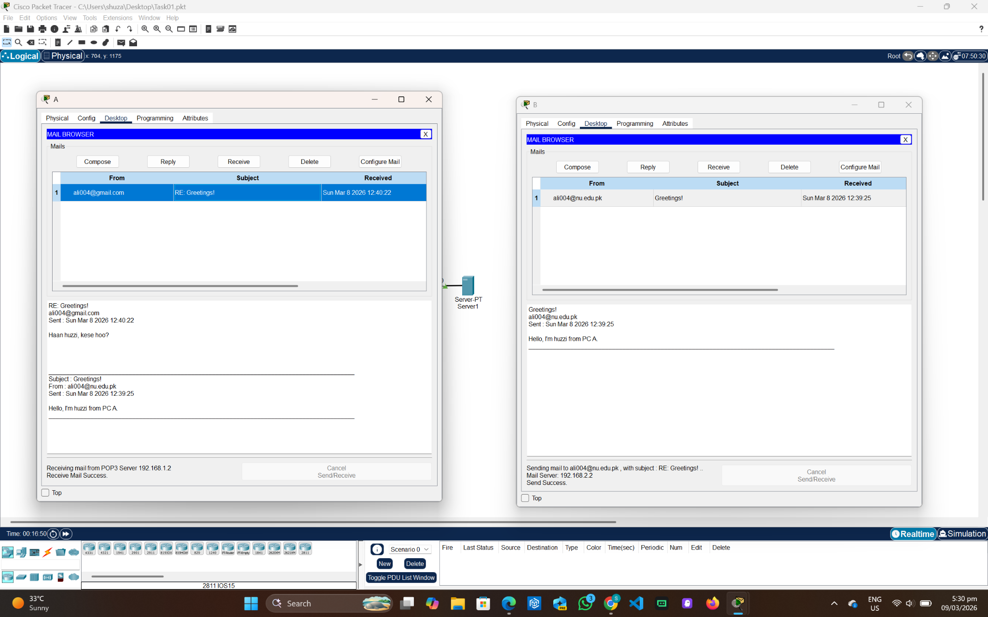
FTP (Server 2):
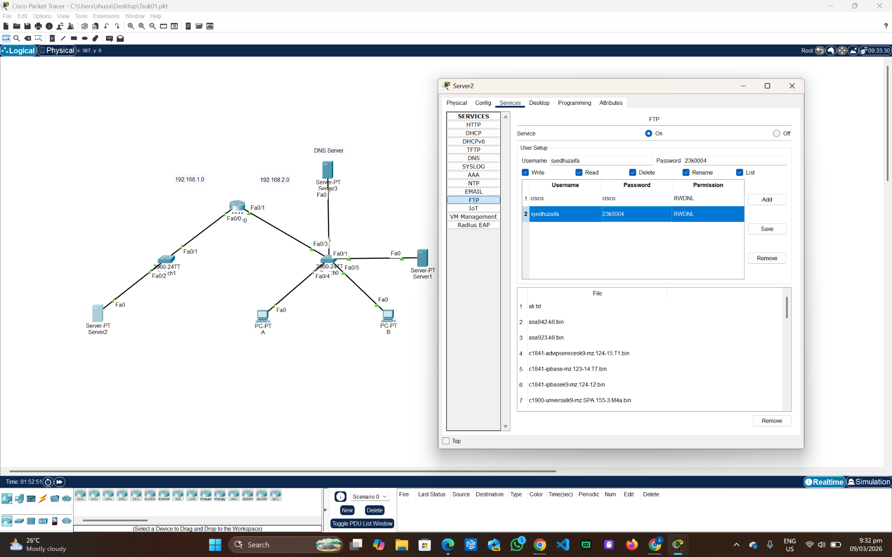
PC-A:
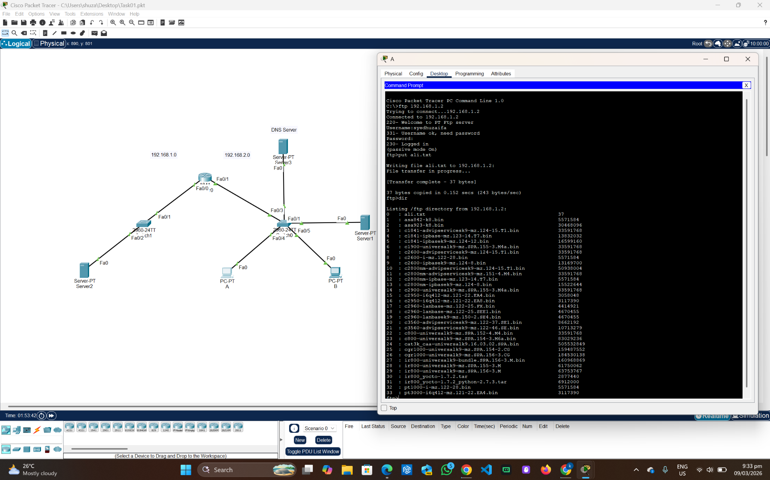
FTP (Server 3):
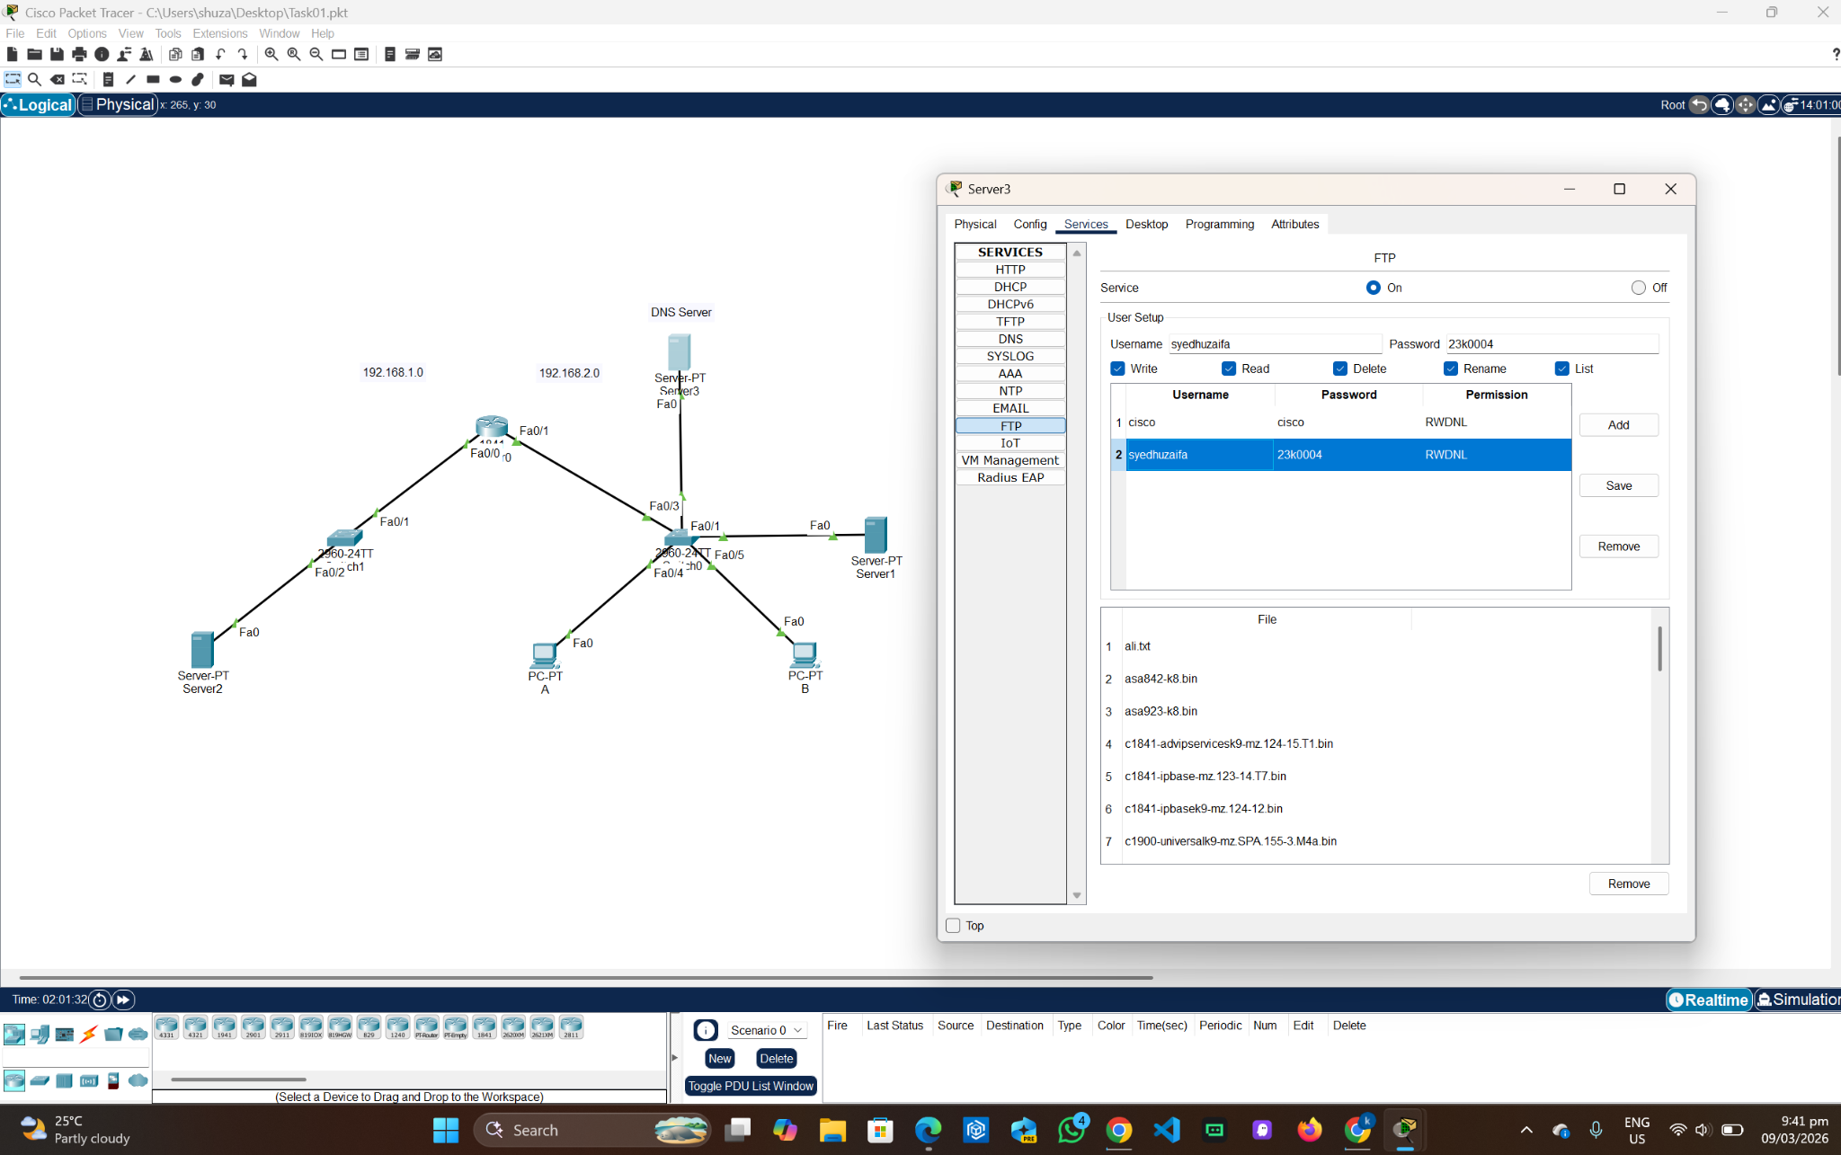
PC-B:
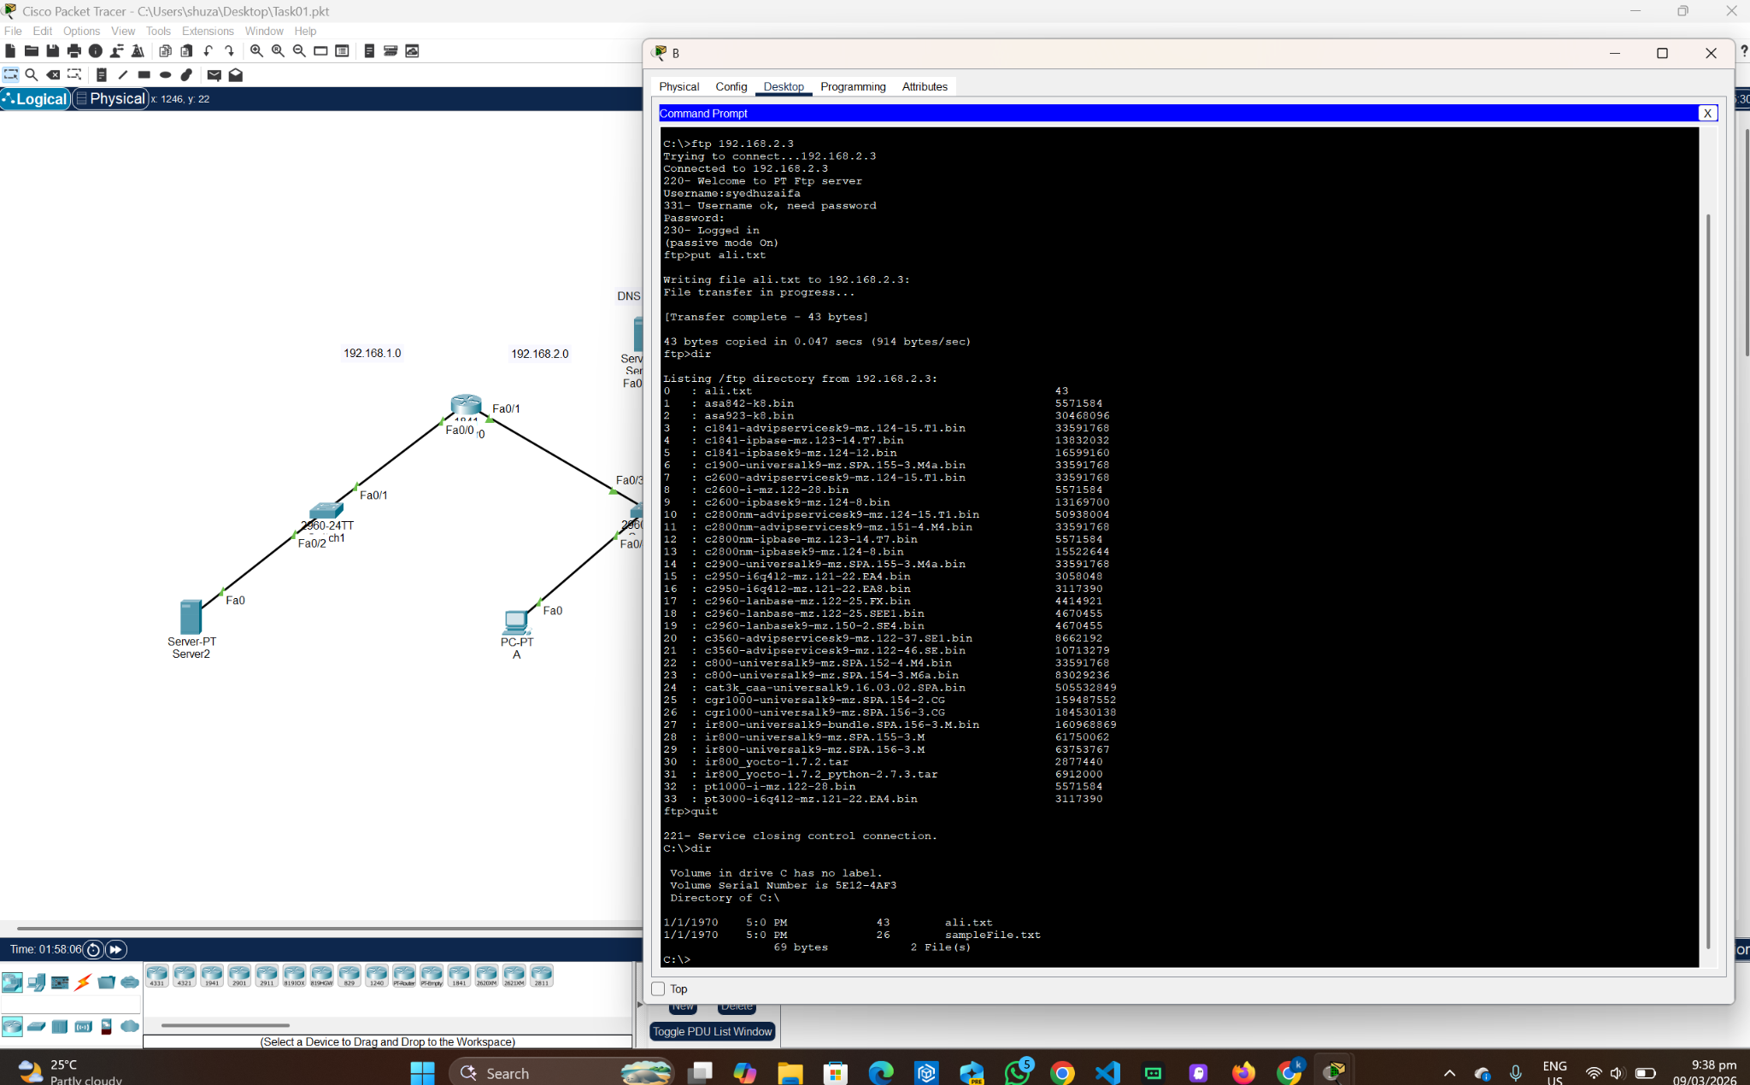

Wireshark Lab:
1. Retrieving Long Documents:
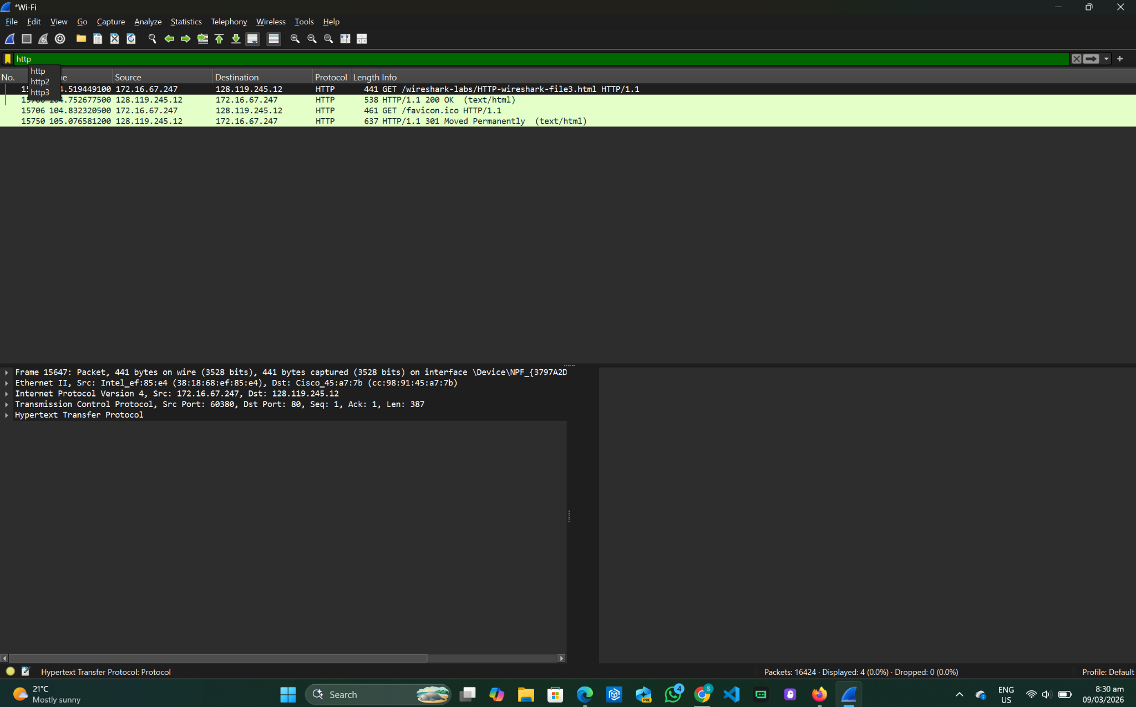
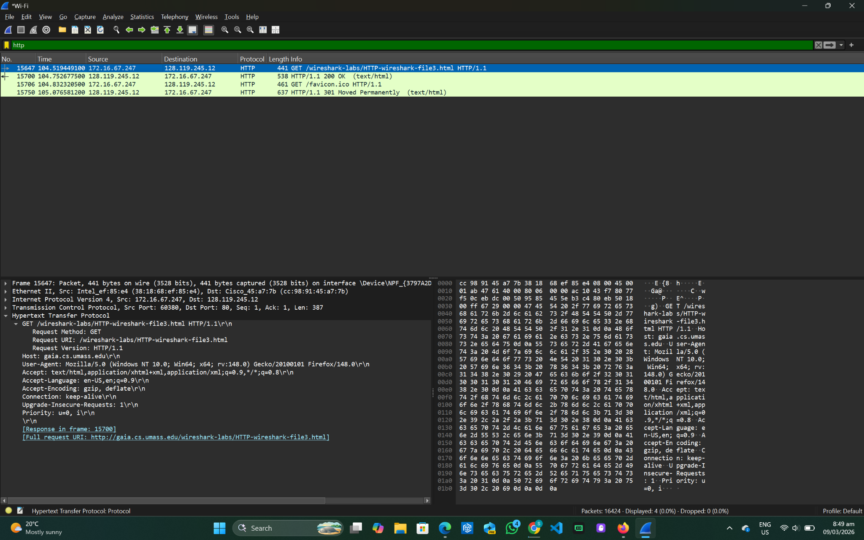
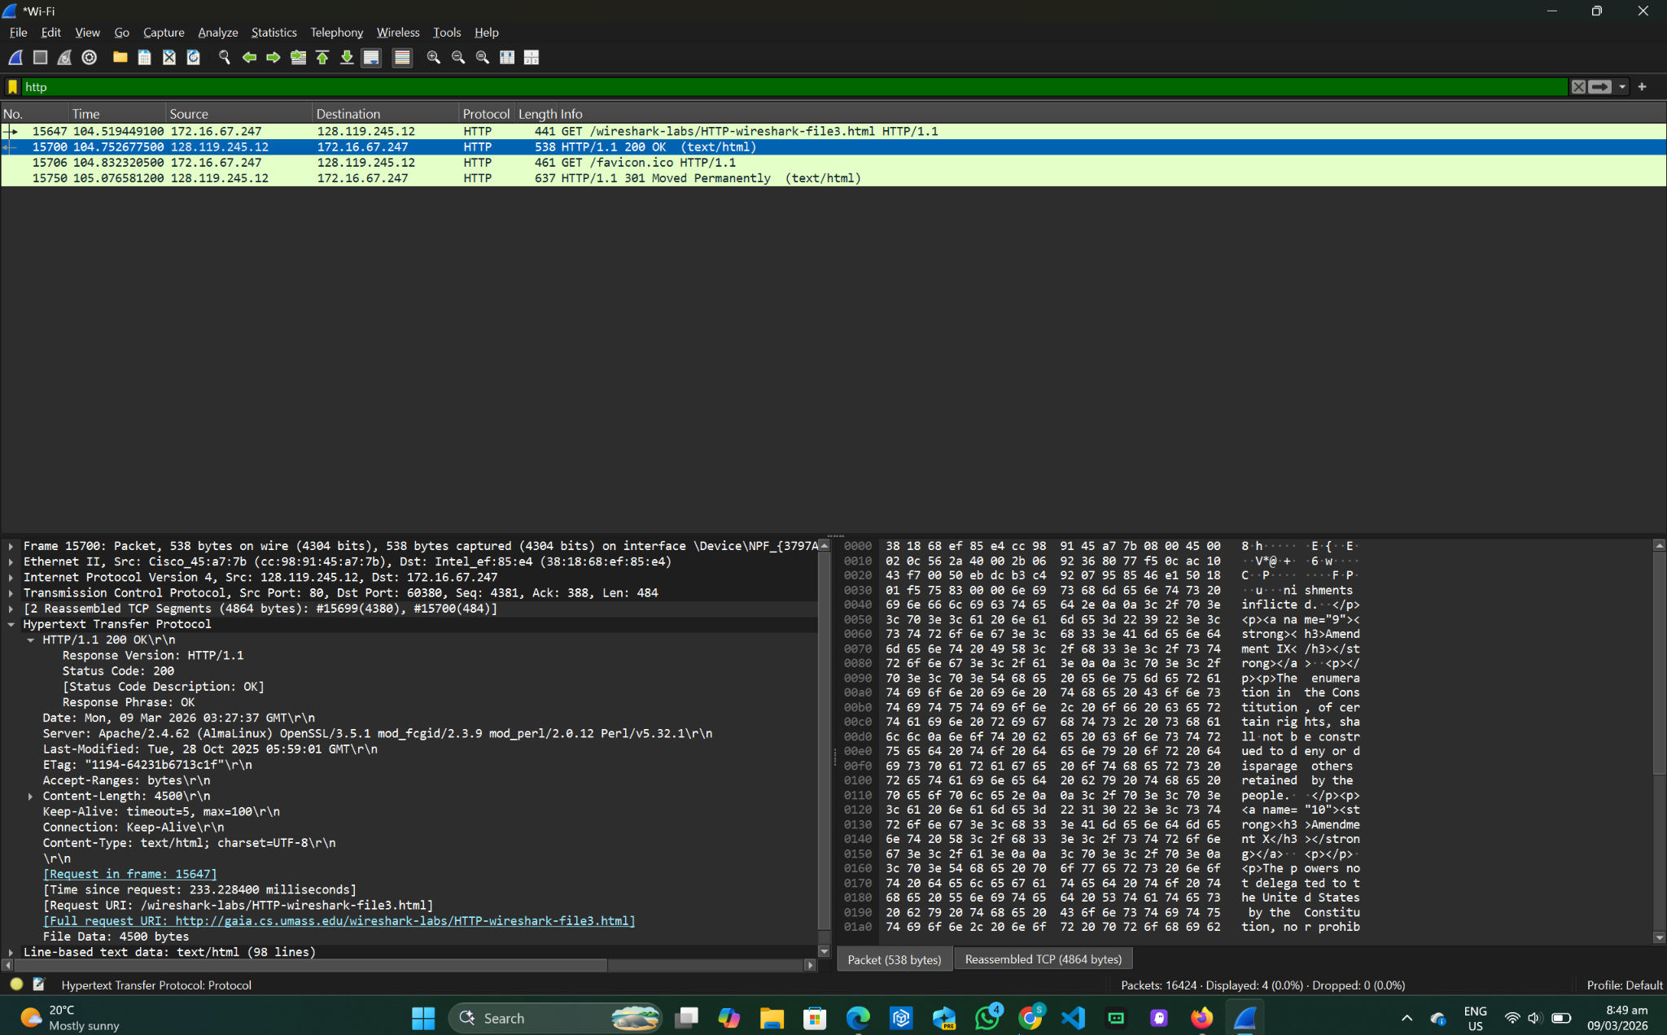

- 2 HTTP requests (1 Base HTML file, 1 favicon). Packet number 15647
- Packet number 15700
- 200 ok
- 2 TCP Packets

2.HTML Documents with Embedded Objects
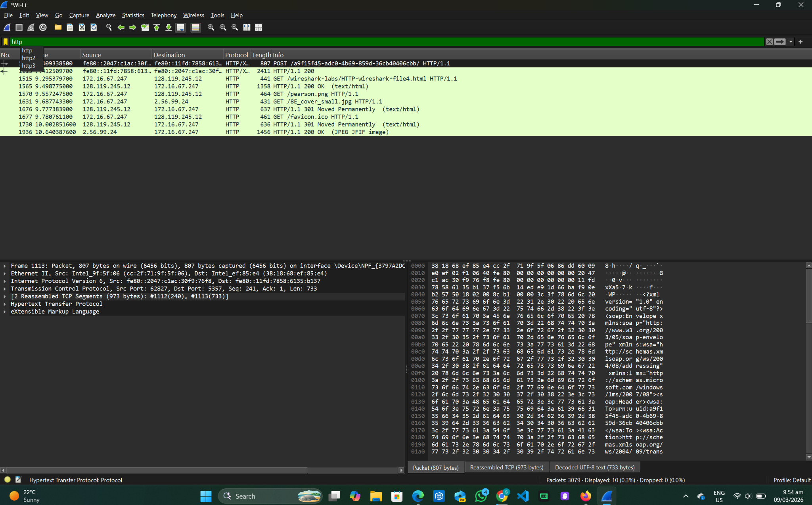

- 4 HTTP Get requests (1 Base HTML, 1 favicon, 2 Images).
Get request 1 was sent to 128.119.245.12
Get request 2 was sent to 128.119.245.12
Get request 3 was sent to 2.56.99.24
- The images were downloaded in parallel because there is a very small time difference between the images which means that the browser didn’t wait for the first image to fully download before requesting the second one.

3. HTTP Authentication
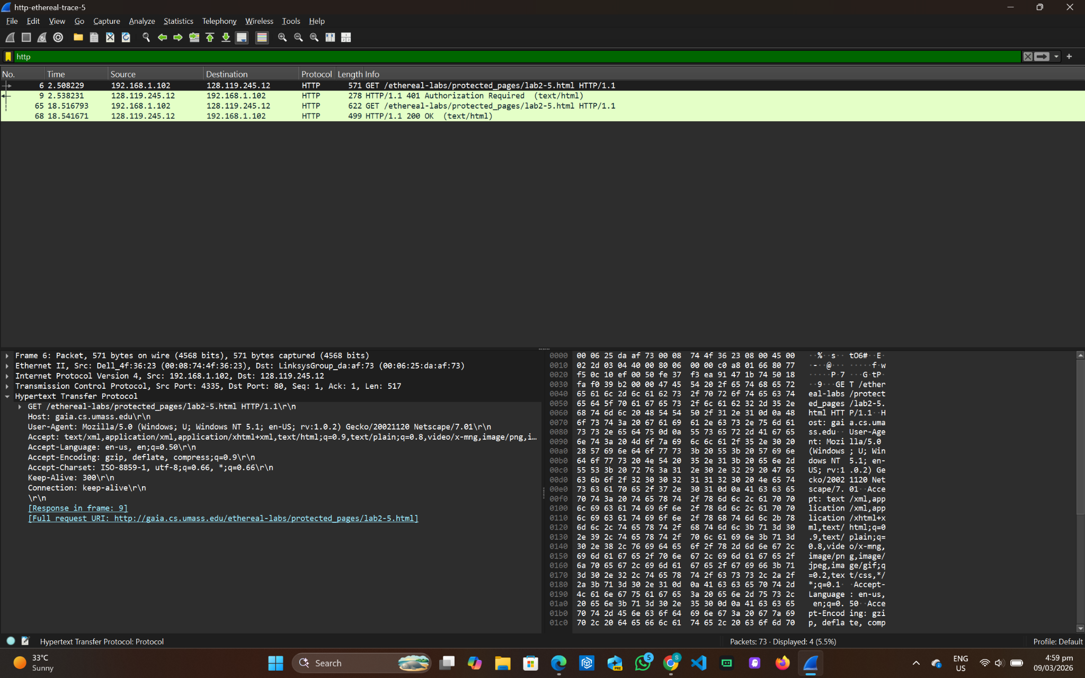

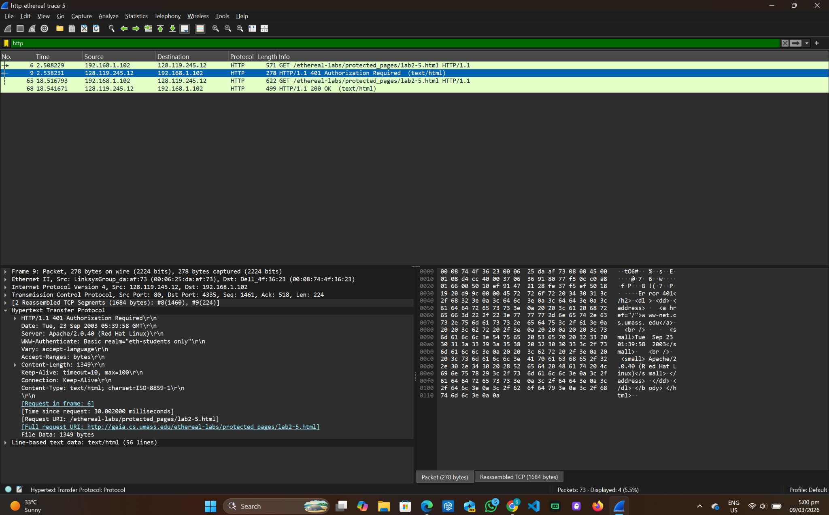
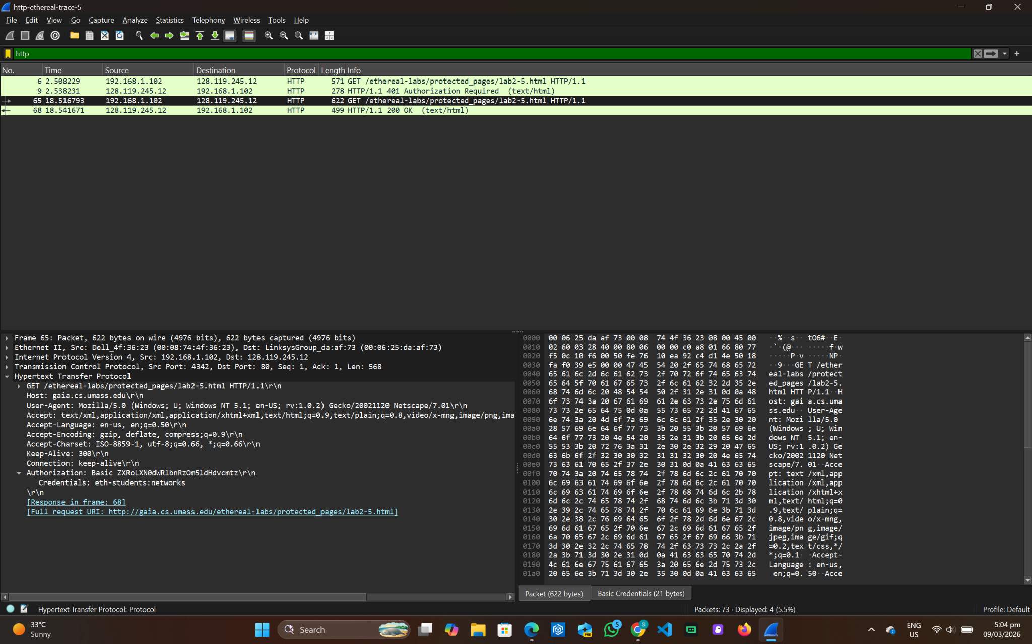

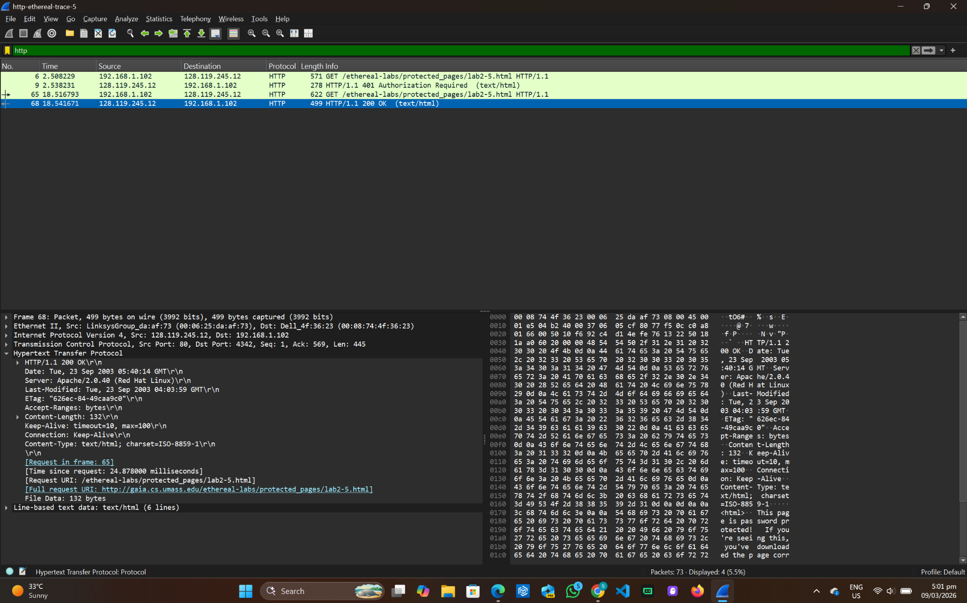

- The server responds with 401 Unauthorized, which requires authentication to load the page.
- The second GET request includes an Authorization header

